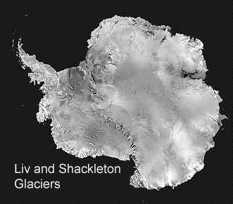
Liv and Shackleton Glaciers Antarctica

- Between which lines of longitude is most of the Shackleton Glacier? ______________________
- Between which lines of longitude is most of the Liv Glacier? _____________________________
- Name 3 smaller glaciers that feed into the Shackleton _________________________________________________
_________________________________________________
- How many nunataks are shown in the Liv Glacier? ________
- What longitude is Mount Wells on? ____________________
- If you stand on Mt. Wells looking east, name 3 nunataks you can see in order from north to south ___________________
_________________________________________________
- Do the Shackleton and Liv Glaciers flow from the top to bottom of the map or the other way round? How do you know? ____________________________________________
_________________________________________________
- Where does the ice come from that flows down these glaciers? __________________________________________
Give the co-ordinates as accurately as you can for:
- Aviator nunatak ______________________
- Roberts Massif ______________________
- Where the McGregor and Gatlin Glaciers meet
_________________________________________

Answers - Liv and Shackleton Glaciers Antarctica

- 176° W and 178° W – 1 mark
- 168° W and 170V W – 1 mark
- Zanefeld, Logie, McGregor, Baldwin, Yeats – 2 marks for 3, 1 mark for 2.
- 3 – 1 mark
- 170° W – 1 mark
- Aviator – June – McKinley – 2 marks for 3 in right order, 1 mark for 2.
- Bottom to top – 1 mark; Contour lines show falling altitude – 1 mark.
- Snow – 1 mark.
1 mark for correct degrees + 1 mark for minutes ± 15 or decimal ± 0.25

- 85° 10’ S 169° W (85.2° S 169° W)
- 85° 30’ S 177° W (85.5° S 177° W)
- 85° 7’ S 173° 45’ W (85.1° S 173.75° W)

Total = 17 marks or 14 marks if disregard minutes in q’s 9-11

