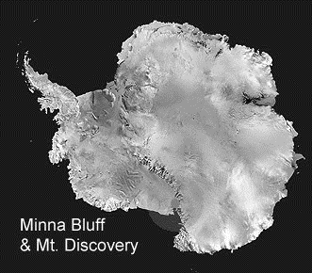
Minna Bluff and Mount Discovery Antarctica

- How long approx. is Minna Bluff? (Minna Saddle to 339 spot height) ________________
- Which is steeper, the north or side of Minna Bluff? How do you know? _________________
__________________________
- How much higher is Mt. Discovery than the next highest point on the map? Show your working __________________
_________________________________________________
- How far is it from Mt. Discovery to the peak of Cape Beck? In km distance and in metres height ______________________
_________________________________________________
- You must journey from Cape Beck to the Eady Ice Piedmont, what direction is the shortest route? Describe your route if you want to avoid gaining or losing height._______________
_________________________________________________
_________________________________________________
_________________________________________________
- Imagine you are standing on Mt. Discovery looking along Minna Bluff describe the landscape around you, use these words in your description.
ridge height steep hook piedmont ice(!)

Answers - Minna Bluff and Mount Discovery Antarctica

- 30km / 19 miles ± 5/3 – 1 mark
- South side – 1 mark; Contour lines closer together
- 2nd highest 1850m – 1 mark; 831m – 1 mark; (2681m – 1850m) – 1 mark.
- 30km / 19 miles ± 5/3 – 1 mark; 2341m (2681 – 340) – 1 mark.
- Across Minna Saddle – 1 mark;
Travel on ice shelf to avoid losing/gaining height – 1 mark;
Go around Minna Bluff on ice shelf to do this – 1 mark.
- Bluff extends in SE direction – 1 mark;
Tall ridge – 1 mark;
Similar height all along – 1 mark;
Ends in hook shape – 1 mark;
Pointing to the south – 1 mark;
Ice piedmont to the right/south – 1 mark;
Surrounded by flat ice shelf – 1 mark;
Mostly ice and snow as far as the eye can see, idea of – 1 mark;
½ mark for appropriately using each of given words.
Other relevant non-repeated observations – 1 bonus mark each.

Total 1-5 = 10 marks.
Q.6 = 11 + bonus marks.

