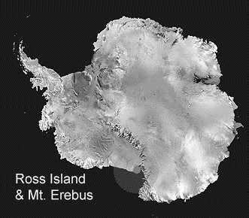
Ross Island and Mount Erebus Antarctica

- Which hut is furthest north? ___________________
- What direction would you travel to reach Marble Point Heliport from the Cape Royds Hut? _______________
- How far would you have to go? _______________________
- What is the nearest line of longitude to the top of Mt. Erebus? ______________________
- What latitude is the Cape Crozier Hut on? _______________
- What is the Ferrar Glacier made of? Does it flow towards or away from McMurdo Sound? _____________________________________
- How long is the Erebus Ice Tongue? Why doesn’t it get any longer? ___________________________________________
- The journey from Cape Evans Hut to McMurdo Station is much easier in the winter than summer, why? What are all the reasons it is harder in summer? ______________________________________________
________________________________________________________
________________________________________________________
________________________________________________________
- Describe Ross Island as fully as you can, use these words in your description.
volcano, historical-huts, glacier, modern-base, mountainous, ice

Answers - Ross Island and Mount Erebus Antarctica

- Cape Crozier Hut – 1 mark
- West – 1 mark
- 65km / 40 miles ± 10/7 – 1 mark
- 167° E – 1 mark
- 77° 30’ S – 1 mark
- Ice - 1 mark; Towards – 1 mark
- 15km / 9 miles ± 5/3 – 1 mark
- No sea-ice in summer – 1 mark;
Have to go over land – 1 – mark;
Crossing glacier – 1 mark;
Avoiding crevasses – 1 mark;
Steep slopes – 1 mark;
Climbing, gaining & losing height, idea of – 1 mark;
Winter can go on flat sea-ice – 1 mark
- Very mountainous, made of (4) volcanoes – 1 mark;
Erebus still active – 1 mark;
Mainly covered in glaciers – 1 mark:
Such as Erebus Glacier – 1 mark:
2 modern bases – 1 mark;
3 historical bases – 1 mark;
Connected permanently to Ross Ice Shelf – 1 mark;
McMurdo Sound frozen in winter, open sea in summer – 1 mark
½ mark for appropriately using each of given words.
Other relevant non-repeated observations – 1 bonus mark each.

Total 1-7 - 7 marks.
Q. 8 = 5 marks
Q.9 = 10 + bonus marks

