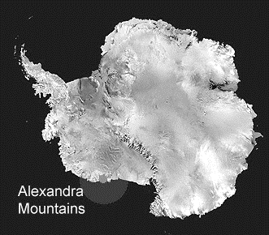
Alexandra Mountains Antarctica

Section A
Which features do these lines pass through?
- A mountain at latitude 77º 15’S ______________________
- A spot height at longitude 155ºW_____________________
- A mountain at longitude 153ºW ______________________
- An island at longitude 153ºW ______________________
- A glacier at latitude 77º 15’S ______________________
- An Ice Shelf at longitude 154ºW ______________________

Section B
Give the co-ordinates as accurately as you can for:
- The seal colony ______________________
- Bowman Peak ______________________
- Scott Nunataks ______________________

Section C
- Approximately how long is Olson Island? ________________
- Approximately how far is Fisher Island from Olson Island?
_________________________________________________
- Could you see Fisher Island from Bowman Peak? Explain your answer ______________________________________
_________________________________________________
- Does the Butler Glacier flow from left to right or right to left? How do you know? _________________________________
_________________________________________________
- Imagine you are standing at the Scott Nunataks, describe the landscape around you, use these words in your description.
higher lower steep plateau glacier ice(!)

Answers - Alexandra Mountains Antarctica

Section A – 1 mark each
- Mount Youngman
- 660m
- Mount Josephine
- Webber Island
- Richter Glacier, accept Cumbie Glacier
- Swinburne Ice Shelf
Section B – 1 mark for correct degrees + 1 mark for minutes ± 15 or decimal ± 0.25
- 77° 5’ S 154° 50’ W (77.1° S 154.85° W)
- 77° 25’ S 153° 30’ W (77.45° S 153.5° W)
- 77° 12’ S 154° 30’W (77.2° S 154.5° W)
Section C
- 11km / 7 miles ±2 - 1 mark
- 20km / 12 miles ±3 - 1 mark
- No - 1 mark, mountains or similar in the way – 1 mark
- L to R – 1 mark, reference to contour lines or towards sea, or away from land – 1 mark.
- Slope down to sea/ice – 1 mark;
Ice plateau or similar description – 1 mark;
Looking down onto Cumbie glacier – 1 mark;
Named other glacier in sight – 1 mark;
Named Island/s – 1 mark each, up to 2;
Seal colony by sea – 1 mark.
Named appropriate peak – 1 mark each up to 2.
½ mark for appropriately using each of given words.
Other relevant non-repeated observations – 1 bonus mark each.
Sections A and B - 18 marks max.
Section C – 12 marks + bonus marks
