Travel in Antarctica – Dog Sled, Miles and Seasons
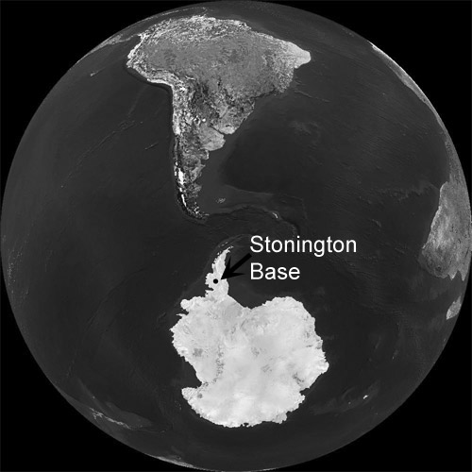
All distances in miles
 | Days in field | Total miles | Total travel |  | Total Lie-up | Total working | %  Travel | %  Lie-up | %  Work | Travel average | Daily average
Autumn '71 | 42 | 137 |  | 22 | 14 | 6 | 52 | 34 | 15 | 6.2 | 3.3
Winter '71 | 54 | 245 |  | 26 | 29 | n/a | 46 | 54 | n/a | 9.8 | 4.5
Summer '71 & '72 stats by month
 | Days in Field | Total Miles | Total  Travel | Total  Lie-up | Total  Working | % Travel | %  Lie-up | % Work | Travel Average | Daily  Average
September | 22 | 174.4 | 14 | 5 | 3 | 63.6 | 22.7 | 13.6 | 12.5 | 7.9
October | 31 | 243.2 | 20 | 10 | 1 | 64.5 | 32.3 | 3.2 | 12.2 | 7.8
November | 30 | 227 | 19 | 5 | 6 | 63.3 | 16.7 | 20.0 | 11.9 | 7.6
December | 31 | 394 | 21 | 2 | 8 | 67.7 | 6.5 | 25.8 | 18.8 | 12.7
January | 27 | 251.3 | 18 | 7 | 2 | 66.7 | 25.9 | 7.4 | 14.0 | 9.3
Total | 141 | 1289.9 | 92 | 29 | 20 | 65.2 | 20.6 | 14.2 | 14.0 | 9.1
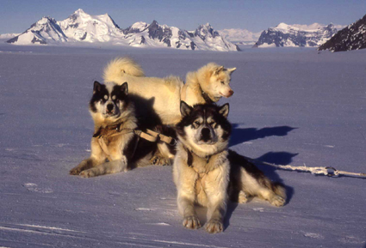

Questions
- How many miles per day on average were travelled during each of the three seasons?
- During which season was travel easiest? Why do you think this was?
- In which summer month were the most miles per day travelled? Why do you think this was?
- Why is there a difference between the “Travel average” and “Daily average” columns?
- What was the season or month with the greatest number of lie-up days? Why do you think there is a difference between the seasons?
Making graphs and charts, some suggestions as to what graphics can be generated from this data.
- Bar or pie chart of miles per day by season.
- Bar or pie chart by season or month to show the time spent travelling, in lie-up and working.
- Bar or pie chart of daily average mileage by season.

