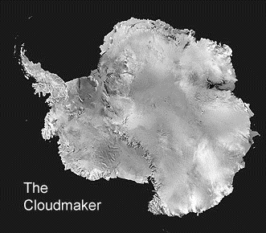
Cloudmaker Mountain and Beardmore Glacier Antarctica

- How high is the top of the Cloudmaker above the Beardmore Glacier? Show how you work this out ___________
_________________________
_________________________
- Describe the slope from the top of the Cloudmaker down to the glacier ________________________________________
_________________________________________________
- If you went from the peak of the Cloudmaker to the spot height at 2660m (under the “H” of Hewson) how much height would you lose and then gain? _____________________________________________
- Describe the area behind the Cloudmaker away from the glacier as fully as you can ____________________________
_________________________________________________
_________________________________________________
- Why are there so many crevasses in the glacier? __________
_________________________________________________
_________________________________________________
_________________________________________________
- What is the name of the highest mountain on the map? How high is it and how much higher is this than the Cloudmaker?
_________________________________________________
- How far is it approximately from the Cloudmaker to Barnes Peak? In km distance and m in height difference. _________________________________________________
Answers - Cloudmaker Mountain and Beardmore Glacier Antarctica

- 1681m ± 200m – 1 mark; Spot height 2681m – 800m or 1000m contour on glacier. – 1 mark
- Very steep – 1 mark. Rocky / little or no snow/ice – 1 mark
- Lose 881m (2681 spot – 1800 contour) – 1 mark, Gain 860m (1800 contour – 2660 spot) – 1 mark.
- Flat/plateau, idea of – 1 mark; High – 1 mark; More mountains/peaks – 1 mark;
- Glacier is ice – 1 mark;
Ice is solid/inflexible – 1 mark;
Glacier floor/under-ice is not flat/smooth – 1 mark;
Glacier moves/flows – 1 mark;
Over bumps/unevenness, idea of – 1 mark;
This cracks the ice and causes crevasses – 1 mark.
- Mount Dickerson – 1 mark; 1439m (4120-2681) – 1 mark.
- 21 ± 4km – 1 mark; 679m – 1 mark.

Total = 19 marks

